# 

# 

# Introduction:

As nations within the European Union attempt to rapidly shift towards clean energy sources and shut down nuclear power plants; an unprecedented energy crisis has emerged which has consequentially accelerated the cost-of-living crisis in Europe where increasing food and energy poverty has resulted in continent-wide civil unrest as millions of European citizens are at the brink of financial disaster.

The crisis came as a result of the Russian invasion of Ukraine which led to a mass exodus of 7.8 million Ukrainian refugees into Europe, which was followed by a series of Russian sanctions which prohibited the exportation of Russian crude oil into Europe and has accelerated an already growing food shortage crisis in the Baltic region, with estimates suggesting that 44 million people are at the brink of famine within the region as a result of the invasion, Covid-19 and climate change.

The energy crisis in addition to the Russian invasion has resulted in an energy inflation markup of up to 40.2% which has resulted in 50 million households reporting that they are living in fuel poverty which is heightened by the effects of climate change. Moreover, thousands of micro, small and medium-sized enterprises are at risk of bankruptcy, which is leading to a rise in unemployment, thus exacerbating poverty in Europe.

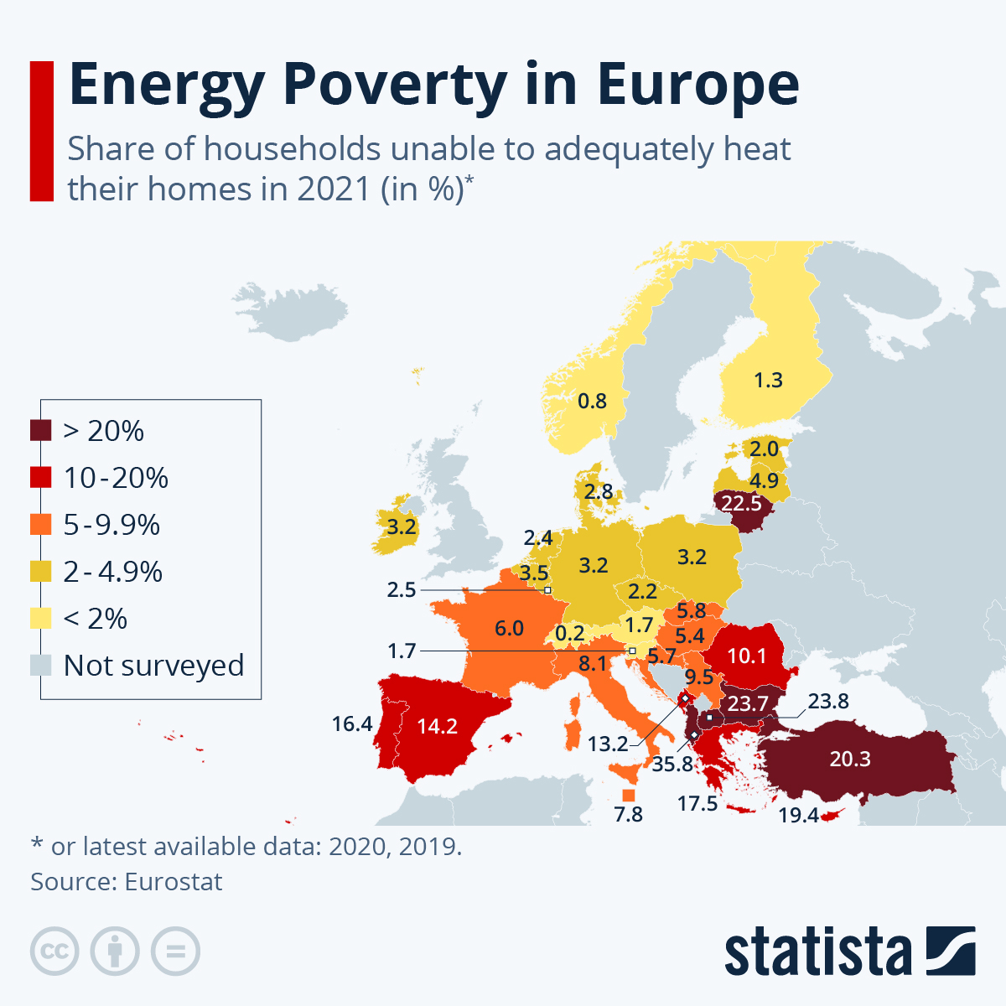

# Why this is an issue?

The rapid rise in energy prices has resulted in a steep increase in fuel poverty throughout Europe which translates to an increase in the inability of households to provide electricity which has direct implications for indoor heating and cooling and makes them susceptible to severe weather conditions which are accentuated by climate change. Furthermore, lack of electricity also prevents basic needs from being met such as a consistent supply of clean water for drinking, sanitation, agriculture and food preservation through refrigeration. The increase in energy costs also has affected businesses which are forced to decrease production to combat the increase in direct costs which consequently resulted in a rise in unemployment and a drop in salaries/wages, thus further exacerbating the fuel-poverty crisis in Europe.

# The case in the Human Rights Council:

The energy crisis was briefly mentioned during the “Human Rights Council discussion regarding Human Rights in Ukraine and in the Democratic Republic of the Congo under its Technical Assistance and Capacity Building Agenda Item” which was held in October 4th, 2022. During these discussions, Russia was accused of being responsible for “the atrocities, destruction and suffering in Ukraine unleashed by this flagrant violation of the United Nations Charter had led to human rights challenges across the world by causing current global economic, food and energy crises.” It was also argued that “Russia should abide by its obligations under international law and end the unlawful deportations and forcible displacements of Ukrainian civilians, including of children; implement the provisional measure order rendered by the International Court of Justice on 16 March; and cease its aggression against Ukraine entirely, unconditionally, and immediately.”

# Recent news/information:

* 95.4 million people in the EU were at risk of poverty or social exclusion, this was equivalent to 21.7% of the EU population.
* The risk of poverty or social exclusion in the EU was higher for women than for men (22.7% compared with 20.7%).
* On September 3rd, 70,000 people protested in Prague where they voiced their opposition to the EU and NATO’s lack of control over soaring energy prices.
* On September 5th, residents in Berlin took to the streets to protest against the government’s energy policies and call for lifting sanctions on Russia to help curb energy price hikes.
* On September 10th, 3,000 protestors took to the streets of Vienna. Many of the protestors condemned the actions of the US-led NATO for provoking conflict and worsening the security situation in Europe .
* US natural gas sales to Europe have reached 200 million dollars of profit.
* European gas price up 400% from a year ago (2022).
* Energy bills for European households will surge by 2 trillion euros at their peak early next year.
* Energy bills will represent 15% of Europes GDP.

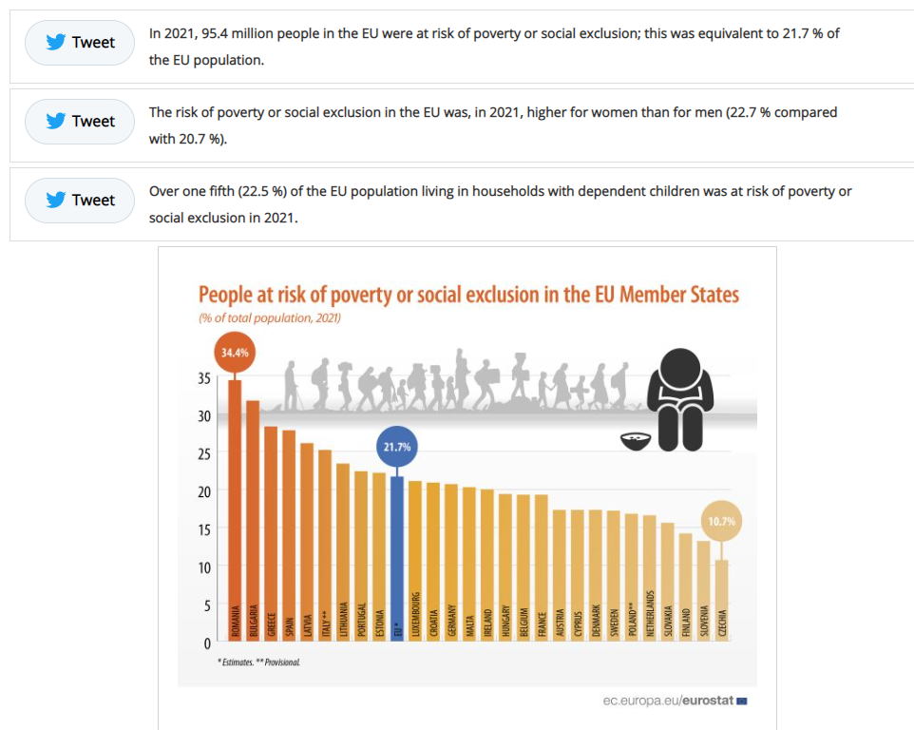

# Great sources on the topic:

Works Cited

Emily. “Do More to Tackle Energy Poverty.” *Open Access Government*, 5 Sept. 2022, [www.openaccessgovernment.org/do-more-to-tackle-energy-poverty-eu-eesc/141181/](http://www.openaccessgovernment.org/do-more-to-tackle-energy-poverty-eu-eesc/141181/). Accessed 20 Nov. 2022.

“Energy Poverty in Europe: What More We Can Do? | Policy Brief | ODYSSEE-MURE.” *Odyssee-Mure.eu*, 2019, [www.odyssee-mure.eu/publications/policy-brief/european-energy-poverty.html](http://www.odyssee-mure.eu/publications/policy-brief/european-energy-poverty.html).

“Europe back to Square One as Gas Prices Go up Again | Worst Winter Yet? | Europe Energy Crisis.” *Www.youtube.com*, [www.youtube.com/watch?v=7rV-oLcVQYI](http://www.youtube.com/watch?v=7rV-oLcVQYI). Accessed 20 Nov. 2022.

“Germany Braces for Oil Shortage, Power Blackouts and Public Anger This Winter | Europe Energy Crisis.” *Www.youtube.com*, [www.youtube.com/watch?v=PmYCdw34oS0](http://www.youtube.com/watch?v=PmYCdw34oS0). Accessed 20 Nov. 2022.

“Here’s Where Energy Poverty Is Felt Most in Europe.” *World Economic Forum*, [www.weforum.org/agenda/2022/11/energy-poverty-in-europe-heating-gas/#:~:text=In%20the%20European%20Union%2C%20nearly](http://www.weforum.org/agenda/2022/11/energy-poverty-in-europe-heating-gas/#:~:text=In%20the%20European%20Union%2C%20nearly). Accessed 20 Nov. 2022.

“Human Rights Council Discusses the Situation of Human Rights in Ukraine and in the Democratic Republic of the Congo under Its Technical Assistance and Capacity Building Agenda Item.” *OHCHR*, [www.ohchr.org/en/press-releases/2022/10/human-rights-council-discusses-situation-human-rights-ukraine-and-democratic](http://www.ohchr.org/en/press-releases/2022/10/human-rights-council-discusses-situation-human-rights-ukraine-and-democratic).

“Soaring Energy Prices Ordeal for European Leaders as Protests Erupt in More Countries - Global Times.” *Www.globaltimes.cn*, [www.globaltimes.cn/page/202209/1275084.shtml](http://www.globaltimes.cn/page/202209/1275084.shtml). Accessed 20 Nov. 2022.

“Widespread Protests Show Support for Ukraine Is Evaporating in Europe amid Economic Crisis.” *Www.youtube.com*, [www.youtube.com/watch?v=rbz_-e9u5Wo](http://www.youtube.com/watch?v=rbz_-e9u5Wo). Accessed 20 Nov. 2022.